OS Assignment-2

Part A:

What will the following commands do?

- echo "Hello, World!" : It prints "Hello, World!" Statement.
- name="Productive" : The String “Productive” is assigned to the name.
- touch file.txt : It creates the empty file using touch command.
- ls -a : Lists all files and directories including hidden files.
- rm file.txt : Removes the file named file.txt.
- cp file1.txt file2.txt : It copies the content of the file1.txt into file2.txt.
- mv file.txt /path/to/directory/ : It moves file.txt to a specified directory.
- chmod 755 script.sh : It changes the permission to read and execute to everyone and writes only to the owner.
- grep "pattern" file.txt : It searches the word “pattern” in the file.txt
- kill PID : It terminates the process.
- mkdir mydir && cd mydir && touch file.txt && echo "Hello, World!" > file.txt && cat file.txt : It creates a directory named mydir and in that it creates the file name file.txt and writes “Hello,World!”,and displays the content in file.txt
- ls -l | grep ".txt" : list the files and directories in that it shows the .txt files
- cat file1.txt file2.txt | sort | uniq : It concatenates the both files and combines the outputs and displays only unique values.
- ls -l | grep "^d" : It lists only directories in that user.
- grep -r "pattern" /path/to/directory/ : it prints the pattern in all the files of that specified directory.
- cat file1.txt file2.txt | sort | uniq –d : It displays the duplicate values in file1.txt and file2.txt
- chmod 644 file.txt : Changes the permissions to readable by everyone and writable by owner.
- cp -r source_directory destination_directory: it copies contents of source directory to destination directory.
- find /path/to/search -name "*.txt" : In the specified directory it searches the .txt files.
- chmod u+x file.txt : it adds execute permission to the owner of the file.txt
- echo $PATH : It prints the value of “$PATH”

Part B:

Identify True or False:

- ls is used to list files and directories in a directory. (TRUE)
- mv is used to move files and directories. (TRUE)
- cd is used to copy files and directories. (FALSE)
- pwd stands for "print working directory" and displays the current directory. (TRUE)
- grep is used to search for patterns in files.(TRUE)
- chmod 755 file.txt gives read, write, and execute permissions to the owner, and read and execute permissions to group and others. (TRUE)
- mkdir -p directory1/directory2 creates nested directories, creating directory2 inside directory1 if directory1 does not exist.(TRUE)
- rm -rf file.txt deletes a file forcefully without confirmation. (TRUE)

Identify the Incorrect Commands:

- chmodx is used to change file permissions. (INCORRECT)
- cpy is used to copy files and directories. (INCORRECT)
- mkfile is used to create a new file. (INCORRECT)
- catx is used to concatenate files. (INCORRECT)
- rn is used to rename files. (INCORRECT)

Part C:

Question 1: Write a shell script that prints "Hello, World!" to the terminal.


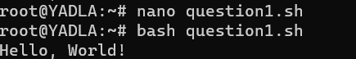

Question 2: Declare a variable named "name" and assign the value "CDAC Mumbai" to it. Print the value of the variable.

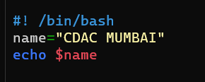
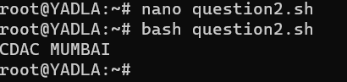

Question 3: Write a shell script that takes a number as input from the user and prints it.

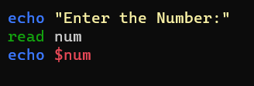
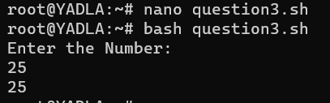

Question 4: Write a shell script that performs addition of two numbers (e.g., 5 and 3) and prints the result.

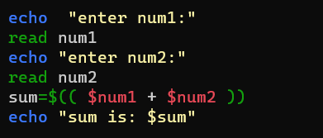
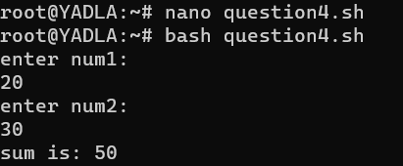

Question 5: Write a shell script that takes a number as input and prints "Even" if it is even, otherwise prints "Odd".

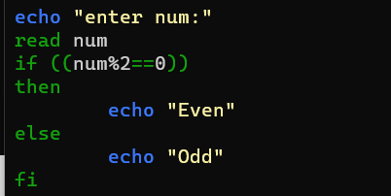
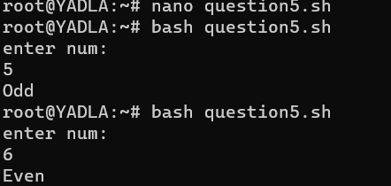

Question 6: Write a shell script that uses a for loop to print numbers from 1 to 5.

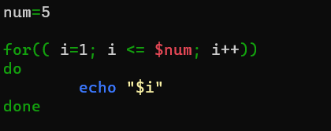
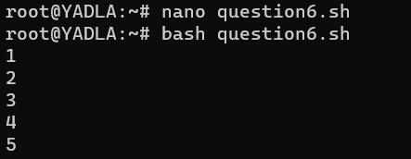

Question 7: Write a shell script that uses a while loop to print numbers from 1 to 5.

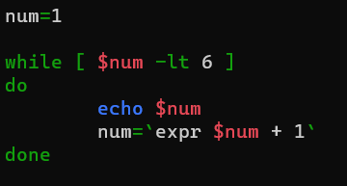
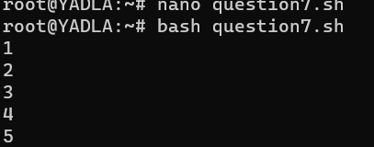

Question 8: Write a shell script that checks if a file named "file.txt" exists in the current directory. If it does, print "File exists", otherwise, print "File does not exist"

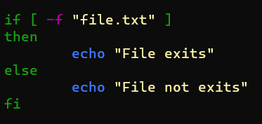
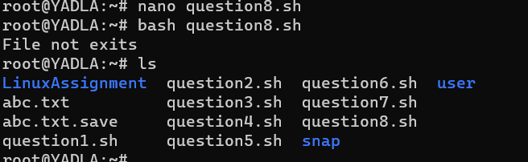

Question 9: Write a shell script that uses the if statement to check if a number is greater than 10 and prints a message accordingly.

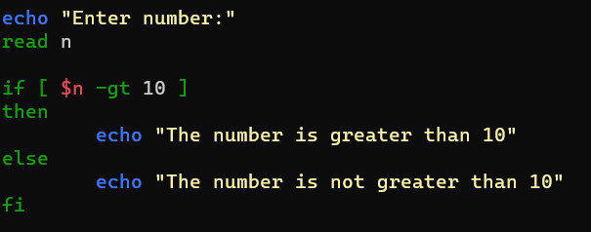
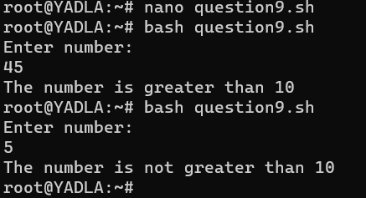

Question 10: Write a shell script that uses nested for loops to print a multiplication table for numbers from 1 to 5. The output should be formatted nicely, with each row representing a number and each column representing the multiplication result for that number.

Question 11: Write a shell script that uses a while loop to read numbers from the user until the user enters a negative number. For each positive number entered, print its square. Use the break statement to exit the loop when a negative number is entered.

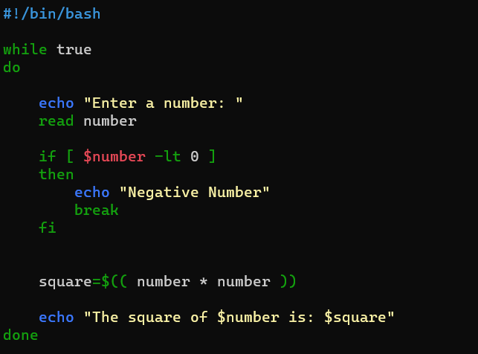
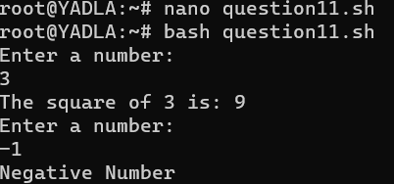

Part E:

1. Consider the following processes with arrival times and burst times:
| Process | Arrival Time | Burst Time |
|---------|--------------|------------|
| P1 | 0 | 5 |
| P2 | 1 | 3 |
| P3 | 2 | 6 |
Calculate the average waiting time using First-Come, First-Served (FCFS) scheduling.
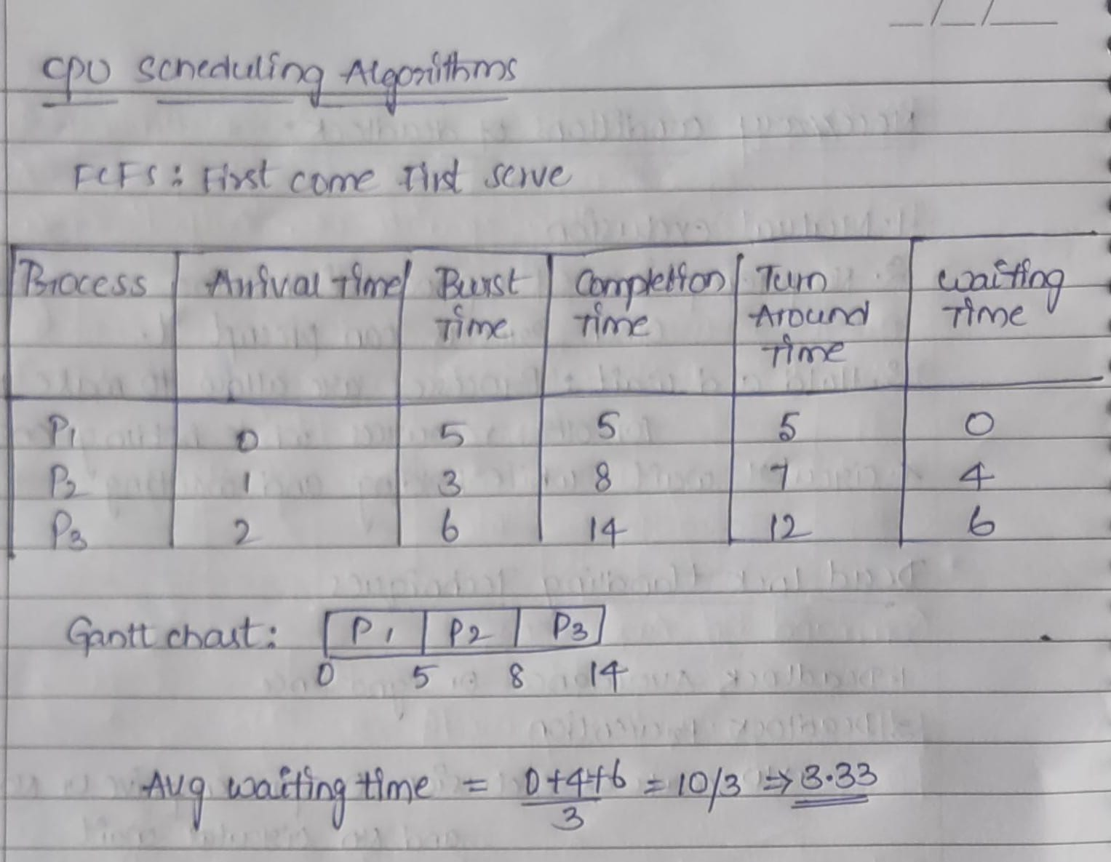

2. Consider the following processes with arrival times and burst times:
| Process | Arrival Time | Burst Time |
|---------|--------------|------------|
| P1 | 0 | 3 |
| P2 | 1 | 5 |
| P3 | 2 | 1 |
| P4| 3|4|
Calculate the average turnaround time using Shortest Job First (SJF) scheduling.
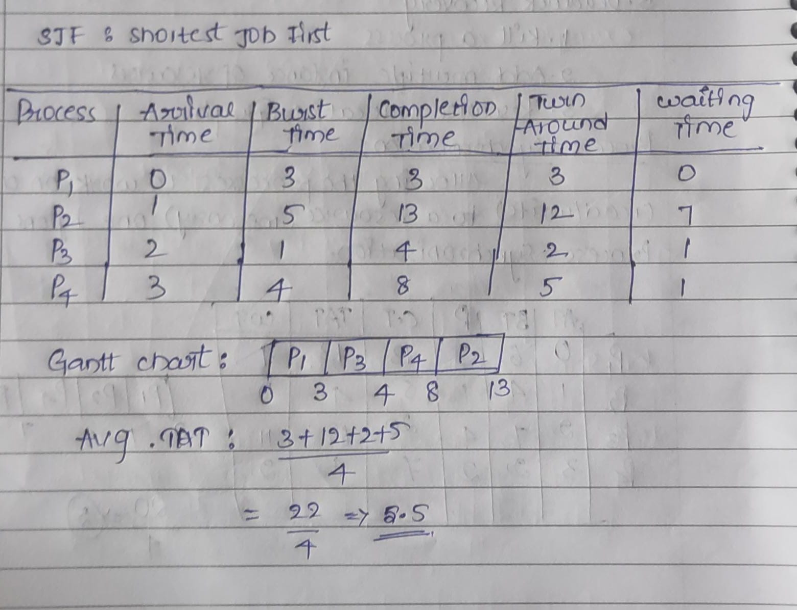

3. Consider the following processes with arrival times, burst times, and priorities (lower number indicates higher priority):
| Process | Arrival Time | Burst Time | Priority |
|---------|--------------|------------|----------|
| P1 | 0 | 6 | 3 |
| P2 | 1 | 4 | 1 |
| P3 | 2 | 7 | 4 |
| P4 | 3 | 2 | 2 | Calculate the average waiting time using Priority Scheduling.

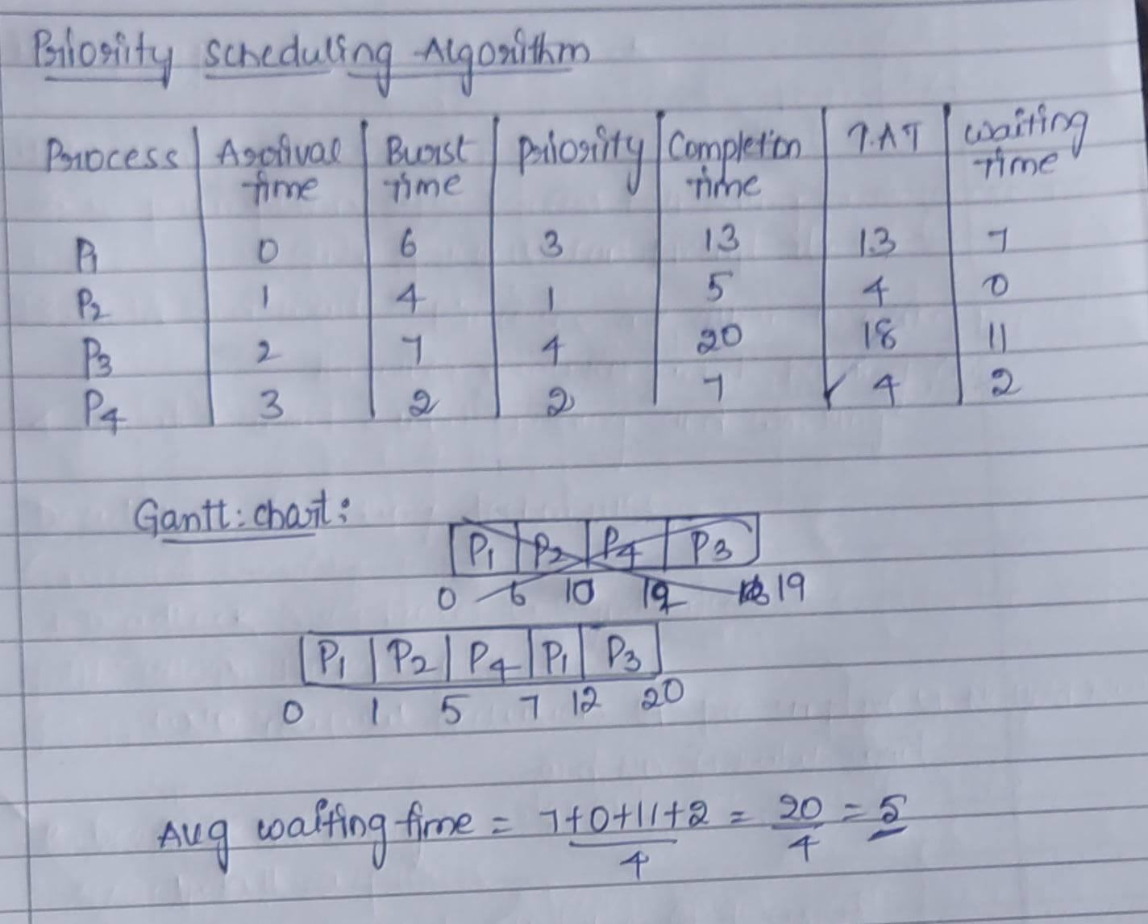

4. Consider the following processes with arrival times and burst times, and the time quantum for Round Robin scheduling is 2 units:
| Process | Arrival Time | Burst Time |
|---------|--------------|------------|
| P1 | 0 | 4 |
| P2 | 1 | 5 |
| P3 | 2 | 2 |
| P4 | 3 | 3 | Calculate the average turnaround time using Round Robin scheduling.

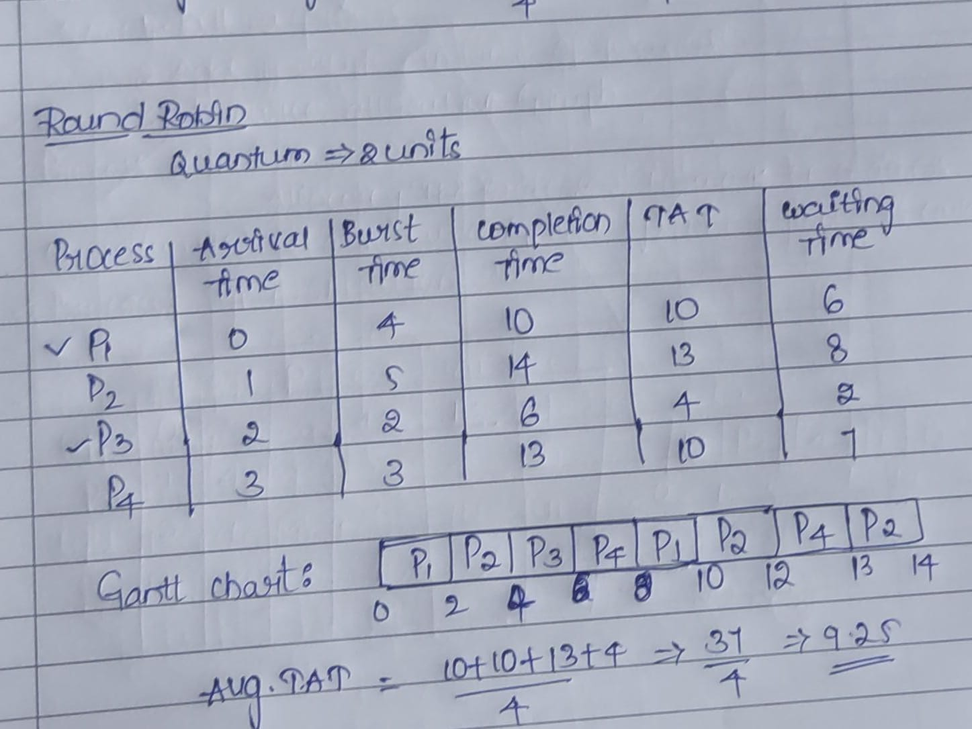

5. Consider a program that uses the fork() system call to create a child process. Initially, the parent process has a variable x with a value of 5. After forking, both the parent and child processes increment the value of x by 1. What will be the final values of x in the parent and child processes after the fork() call?

